***ASSIGNMENT 5***

* **Selenium IDE**

1. **What is Automation Testing ? Ans** : Automation testing is the use of software to control the execution of tests, the comparison of actual outcomes to predicted outcomes, the setting up of test preconditions, and other test control and test reporting functions, In other word automation testing is a process of writing a computer program to do testing that would otherwise need to be done manually.
2. **Which Are The Browsers Supported By Selenium Ide ? Ans** : Google chrome, Mozilla Firefox, and Microsoft edge.
3. **What are the benefits of Automation Testing ? Ans** : 70% faster than the manual testing.

* Wider test coverage of application features.
* Reliable in results.
* Ensure consistency.
* Saves time and cost.
* Improves accuracy.
* Human intervention is not required while execution.
* Increases efficiency.
* Better speed in executing tests.
* Re-usable test scripts.
* Test frequently and thoroughly.
* More cycle of execution can be achieved through automation.
* Early time to market

.

1. **What are the advantages of Selenium ? Ans** : It’s open source, free to use, and free of charge.

* Highly extensible.
* Can run tests across different browsers.
* Supports various operating systems.
* Support mobile devices.
* Can execute tests while the browser is minimized .
* Can execute tests in parallel.

1. **Why testers should opt for Selenium and not QTP ? Ans** : QTP test scripts run only on the windows environment, they cannot be run across all browsers. while selenium supports a wide range of programming languages, selenium is OS independent and allows test scripts to run across all browsers.
2. **To validate the Swaglab website login and logout process page.** https://www.saucedemo.com

**Ans : RUN**

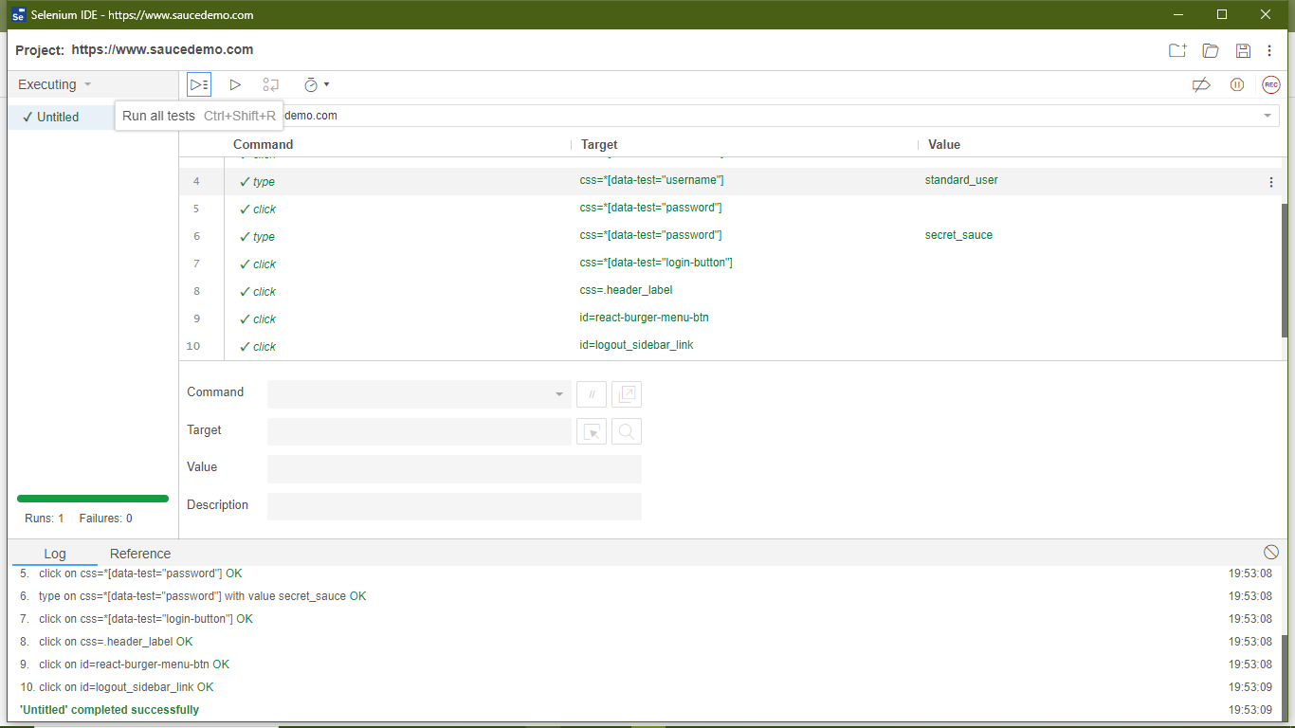

**SCRIPT**

{

"id": "aec509b2-0c1c-4777-b93d-48cb9ae7ea03",

"version": "2.0",

"name": "https://www.saucedemo.com",

"URL": "https://www.saucedemo.com",

"tests": [{

"id": "ee4c00a4-3121-4a89-b312-b74b57746e5a",

"name": "Untitled",

"commands": [{

"id": "92c0633e-c617-4b3f-8958-730ca1d388e0",

"comment": "",

"command": "open",

"target": "/",

"targets": [],

"value": ""

}, {

"id": "e779c13c-c419-4d35-b074-22ef2105bfdb",

"comment": "",

"command": "setWindowSize",

"target": "1382x784",

"targets": [],

"value": ""

}, {

"id": "0b05bfa1-4ef4-466b-8ba8-2df691bd4b0c",

"comment": "",

"command": "click",

"target": "css=*[data-test=\"username\"]",

"targets": [

["css=*[data-test=\"username\"]", "css:data-attr"],

["id=user-name", "id"],

["name=user-name", "name"],

["css=#user-name", "css:finder"],

["xpath=//input[@id='user-name']", "xpath:attributes"],

["xpath=//div[@id='login_button_container']/div/form/div/input", "xpath:idRelative"],

["xpath=//input", "xpath:position"]

],

"value": ""

}, {

"id": "9c5e206b-291c-4649-94ed-93ae5a7d946a",

"comment": "",

"command": "type",

"target": "css=*[data-test=\"username\"]",

"targets": [

["css=*[data-test=\"username\"]", "css:data-attr"],

["id=user-name", "id"],

["name=user-name", "name"],

["css=#user-name", "css:finder"],

["xpath=//input[@id='user-name']", "xpath:attributes"],

["xpath=//div[@id='login_button_container']/div/form/div/input", "xpath:idRelative"],

["xpath=//input", "xpath:position"]

],

"value": "standard_user"

}, {

"id": "e1a7dfb9-7e23-43c0-9e9d-45f21d6f451e",

"comment": "",

"command": "click",

"target": "css=*[data-test=\"password\"]",

"targets": [

["css=*[data-test=\"password\"]", "css:data-attr"],

["id=password", "id"],

["name=password", "name"],

["css=#password", "css:finder"],

["xpath=//input[@id='password']", "xpath:attributes"],

["xpath=//div[@id='login_button_container']/div/form/div[2]/input", "xpath:idRelative"],

["xpath=//div[2]/input", "xpath:position"]

],

"value": ""

}, {

"id": "cce421db-9d1e-470f-9c9e-b35f38f3c2a7",

"comment": "",

"command": "type",

"target": "css=*[data-test=\"password\"]",

"targets": [

["css=*[data-test=\"password\"]", "css:data-attr"],

["id=password", "id"],

["name=password", "name"],

["css=#password", "css:finder"],

["xpath=//input[@id='password']", "xpath:attributes"],

["xpath=//div[@id='login_button_container']/div/form/div[2]/input", "xpath:idRelative"],

["xpath=//div[2]/input", "xpath:position"]

],

"value": "secret_sauce"

}, {

"id": "94e048c2-818b-4e9c-80c8-c52d3af5b656",

"comment": "",

"command": "click",

"target": "css=*[data-test=\"login-button\"]",

"targets": [

["css=*[data-test=\"login-button\"]", "css:data-attr"],

["id=login-button", "id"],

["name=login-button", "name"],

["css=#login-button", "css:finder"],

["xpath=//input[@id='login-button']", "xpath:attributes"],

["xpath=//div[@id='login_button_container']/div/form/input", "xpath:idRelative"],

["xpath=//form/input", "xpath:position"]

],

"value": ""

}, {

"id": "ec5b1f65-a70e-4d05-803d-6129173712d0",

"comment": "",

"command": "click",

"target": "css=.header_label",

"targets": [

["css=.header_label", "css:finder"],

["xpath=//div[@id='header_container']/div/div[2]", "xpath:idRelative"],

["xpath=//body/div/div/div/div/div/div[2]", "xpath:position"]

],

"value": ""

}, {

"id": "65e2c132-5528-4300-8acc-090470ed9fea",

"comment": "",

"command": "click",

"target": "id=react-burger-menu-btn",

"targets": [

["id=react-burger-menu-btn", "id"],

["css=#react-burger-menu-btn", "css:finder"],

["xpath=//button[@id='react-burger-menu-btn']", "xpath:attributes"],

["xpath=//div[@id='menu_button_container']/div/div/div/button", "xpath:idRelative"],

["xpath=//button", "xpath:position"],

["xpath=//button[contains(.,'Open Menu')]", "xpath:innerText"]

],

"value": ""

}, {

"id": "978682df-2f79-4a41-a11b-16e6cebf3c59",

"comment": "",

"command": "click",

"target": "id=logout_sidebar_link",

"targets": [

["id=logout_sidebar_link", "id"],

["linkText=Logout", "linkText"],

["css=#logout_sidebar_link", "css:finder"],

["xpath=//a[contains(text(),'Logout')]", "xpath:link"],

["xpath=//a[@id='logout_sidebar_link']", "xpath:attributes"],

["xpath=//div[@id='menu_button_container']/div/div[2]/div/nav/a[3]", "xpath:idRelative"],

["xpath=(//a[contains(@href, '#')])[2]", "xpath:href"],

["xpath=//a[3]", "xpath:position"],

["xpath=//a[contains(.,'Logout')]", "xpath:innerText"]

],

"value": ""

}]

}],

"suites": [{

"id": "e74ab8e7-e3ee-44b2-929f-2e3ba0f812db",

"name": "Default Suite",

"persistSession": false,

"parallel": false,

"timeout": 300,

"tests": ["ee4c00a4-3121-4a89-b312-b74b57746e5a"]

}],

"urls": ["https://www.saucedemo.com/"],

"plugins": []

}